PLANNED REGULAR DONATIONS

Dear Supporter,

Thank you for considering becoming a financial contributor to Puddle

Jumpers Inc It is only because of support from people like you that

we are able to continue offering quality experiences to children, young

people & families who are experiencing disadvantage.

Yours sincerely,

**Melanie Tate, CEO & Founder**

Name: .....................................................................

Contact Phone: .......................................................

Contact Email: ................................................................................................

Address: ……………………................................................ Suburb: …………............ Postcode: ..............

**GIVING OPTIONS (All donations are tax deductible)**

You might like to make a one-off donation or commit to a Regular pledge. Please fill in the following information and return this form to Puddle Jumpers Inc.

**Puddle Jumpers Incorporated**

52 Pleasant Avenue

GLANDORE SA 5037

Ph: 0400 999 349

[www.puddlejumpers.org.au](http://www.puddlejumpers.org.au)

Email: [mtate@jumpinallthepuddles.org](mailto:mtate@jumpinallthepuddles.org)

* I would like to donate *(PLEASE CIRCLE OR HIGHLIGHT)*;
  + - $2
    - $5
    - $10
    - $15
    - 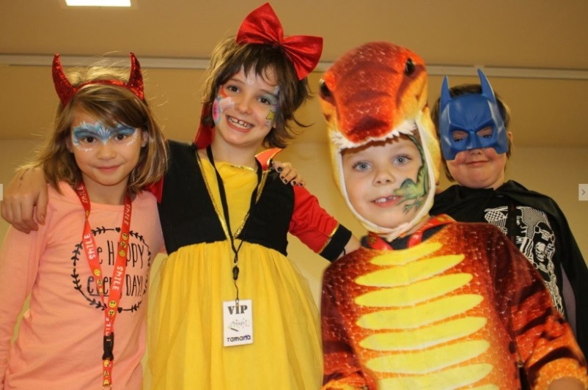 $20
    - $25
    - OTHER $___________
* I would my pledge to be taken out *(PLEASE CIRCLE OR HIGHLIGHT)*;
  + - Weekly
    - Fortnightly
    - Monthly
    - Once Off ONLY

Please charge my:

**Credit Card** _____**Visa**______  **MasterCard**____

Card Number: _ _ _ _ / _ _ _ _ / _ _ _ _ /_ _ _ _ Card Expiry Date: _ _ / _ _ _ CVV: _ _ _

Name on Card: .............................................................Signature: _______________________________

**Thank you for Supporting Puddle Jumpers Inc**

**Your donation will help us help more kids!**

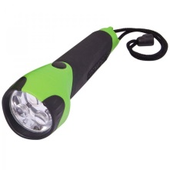[](http://www.google.com.au/imgres?imgurl=http://www.istockphoto.com/file_thumbview_approve/4194890/2/istockphoto_4194890-soccer-ball-isolated-on-white.jpg&imgrefurl=http://www.istockphoto.com/stock-photo-4194890-soccer-ball-isolated-on-white.php&usg=__bzFhvsTFpKyOkxyBtJ_hdgRSOL4=&h=380&w=380&sz=33&hl=en&start=24&zoom=1&tbnid=vYyGmQ041ujhxM:&tbnh=132&tbnw=131&ei=3S6-TZz3KISosQODqoDjBQ&prev=/search?q%3Dsoccer%2Bball%26hl%3Den%26biw%3D1362%26bih%3D583%26gbv%3D2%26tbm%3Disch&itbs=1&iact=rc&dur=1341&page=2&ndsp=24&ved=1t:429,r:6,s:24&tx=65&ty=32)**$5** donation – buys a new soccer ball (or other sport equipment) for camps

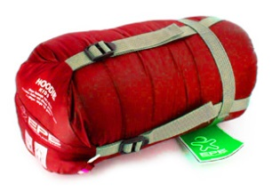**$10** donation – buys a child a hat and torch for camp

**$20** donation – buys a child a sleeping bag for camp

**$50** donation – buys paint brushes for a craft activity on camp

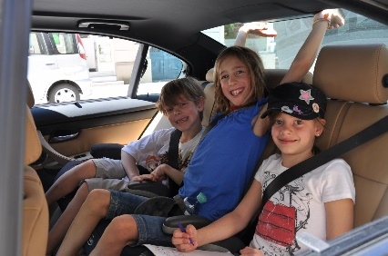**$75** donation – buys transport for 3 children to and from camp

**$100** donation – buys 4 teenage boys Christmas presents

**$150** donation – funds a volunteer mentor’s attendance on a camp

**$300** donation – funds a bus excursion for a camp (20 children)

**$ 500** donation – buys an activity facilitator for a camp (i.e. CSIRO to run science experiment activity)

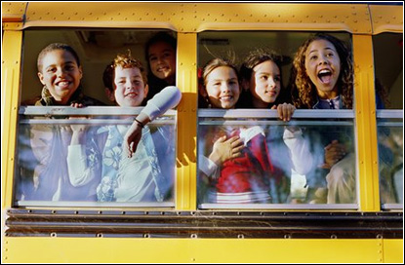

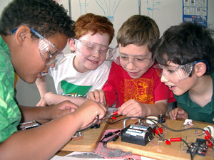**$1500** donation – buys an entire week-long camps food for the participants / volunteers

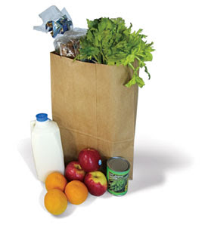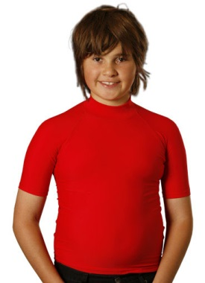**$2000** donation – funds an entire week-long camps accommodation

**$3000** donation – funds an activity day for 50 children

**$4000** donation – buys 50 Puddle Jumpers Inc swim /rash vests & hats for camps

**$5000** donation – funds an entire weekend camp for 20 children / young people and their families

**$6000** donation – funds a Family Fun Day for over 100 families

**$10,000** donation – funds an entire week-long camp for 20 children/young people and 25 volunteers!